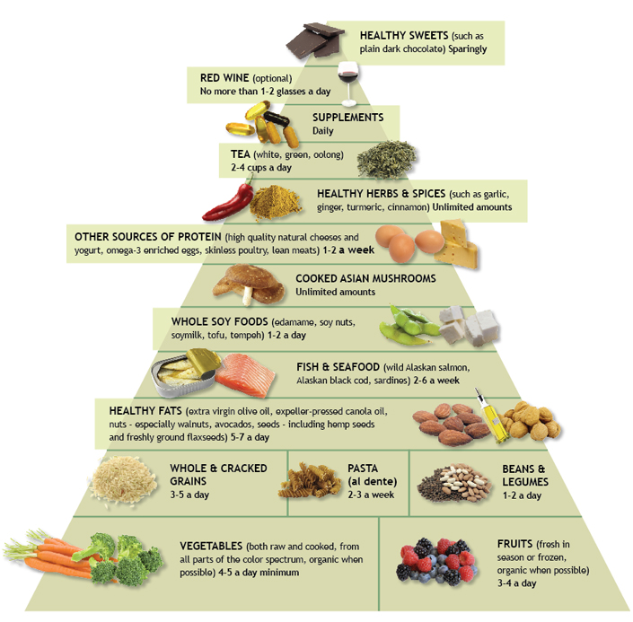
http://www.drweil.com/drw/ecs/pyramid/press-foodpyramid.html

Cheryl LeCroy CreativeJuicesConsulting.com 864-723-2442
Cheryl@CreativeJuicesConsulting.com

