Gardening for the anti-inflammatory diet
Know your ZONE: Charlotte 7a
www.planthardiness.ars.usda.gov/PHZMWeb
http://www.plantmaps.com/interactive-north-carolina-usda-plant-zone-hardiness-map.php
When to Plant: The selection at your home store (Lowes, Home Depot, Ace, etc.) is in season. They do the zone and plant chart homework for you.
https://www.almanac.com/gardening/planting-dates/NC/Charlotte
http://www.ufseeds.com/North-Carolina-Vegetable-Planting-Calendar.html
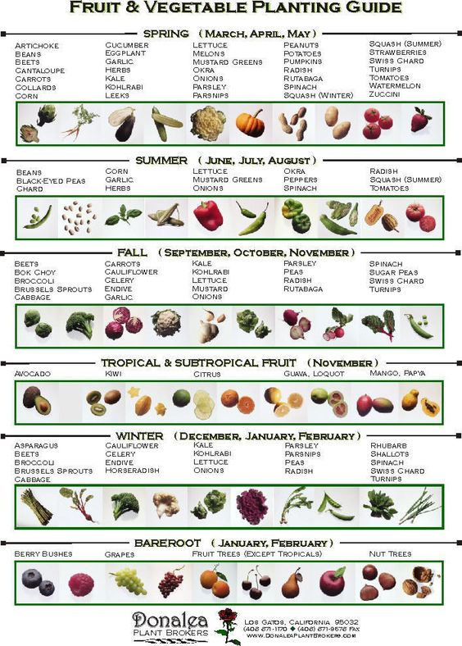 1
Window Sill and Indoor Gardening
Vegetable gardening indoors has most of the same requirements as an outdoor garden: bright light, water, nutrients, and protection from pests and diseases. Since space is likely to be more limited growing crops indoors, choosing quick-maturing crops planted in quick succession is your best strategy; for example, sow a few seeds of leaf lettuce each week and harvest leaves often while they are still young and tender.
Crops. Choose compact, miniature, or dwarf varieties of crops and crops that are quick maturing. Small, quick-growing crops will require less space and time to reach harvest.
Choose plants during their natural growing season. Cool-weather crops such as leaf crops and root crops are a good choice for the autumn and winter indoor garden; these crops naturally require less bright light. Warm-weather crops–fruiting vegetables such as tomatoes and peppers–require longer days to ripen, so planting these in spring and summer makes sense.
Spring and summer crops include tomatoes, peppers, eggplants, bush beans, and most herbs. These crops require eight hours of sunshine or bright light and a room consistently warm.
Crops not suited to windowsill growing are tall and vining crops such as corn, pole beans, squash, melons, and pumpkins.
Planting. Plant indoor crops in pots that will allow roots plenty of room to grow; a single lettuce plant can grow in a gallon pot, a small tomato plant will require a 3 to 5 gallon container. Choose a commercial potting soil with a medium-texture that will hold moisture. Recipe for home-made soil. 2 parts garden soil, 2 parts finished compost, 1 part peat moss, and 1 part vermiculite or perlite.
Sow seeds just as you would in the garden and thin plants to the strongest seedling from two to three weeks after germination when seedlings have grown their first true leaves and have gained strength. Snip away the weakest seedlings at soil level with a small scissors.
If you plant more than one crop in a container, don’t plant them too close together or they will compete for light, water, and nutrients–resulting in weak plants all around.
Light. Growing vegetables indoors requires bright sunlight just like outdoors or bright artificial light. A south-facing bay window that gets light from the south, east, and west is an ideal place for a window garden. Windows that are not in the shadow of eves are best. Placing your indoor garden in a white or light colored room will help as well; light colors reflect light; dark interior surfaces will absorb light.
Salad greens and herbs require less sunshine; but they still require bright light.
Temperature. Summer crops grow best at temperatures between 75° and 85°F in the daytime and 60° and 75°F at night. Autumn and winter or cool-weather crops grow best at temperatures between 60° and 65°F in the daytime and around 50°F at night. Plant with warm roots can with stand air temperatures 5° to 10°F cooler than recommended; a heating pad made for plants can help. Good air circulation indoors will help keep plants healthy.
Water. Water indoor crops as needed; stick your finger in the soil and if it comes out dry water; if it is damp or wet don’t. Too much water can result in fungus disease. Water indoor crops in the morning on sunny days when possible; evaporation will be slowed on cloudy and cool days. Plants require less water in winter. Use room temperature water.
Feed. Feed indoor, container-grown plants every other week. Compost tea and liquid fish emulsion are rich organic liquid fertilizers. Fertilize less when temperatures are cool.

2
Best container plants

Tomatoes
Basil
Zucchini &Summer Squash
Parsley
Oregano
Strawberries
Rosemary
Peppers
Chives
Spinach
Thyme
Sage
Cucumbers
Kale
Lettuce
Radish
Potatoes
Carrots
Beets
Turnips
Sugar snap peas

In Ground Gardening

From seed
Beans
Corn
Watermelon
Peas
Cucumbers
Squash

Okra
Beets
Carrots
Lettuce
Pumpkins
Radishes

Start from Plants
Eggplant
Tomatoes
Peppers
Strawberries
Stevia
Basil

3
Heirloom Vegetables
The term heirloom vegetable is used to describe any type of vegetable seed that has been saved and grown for a period of years and is passed down by the gardener that preserved it. To be capable of being saved, all heirloom seed must be open pollinated.
Open pollinated or OP plants are simply varieties that are capable of producing seeds that will produce seedlings just like the parent plant. Not all plants do this, especially hybrid plants.
Hybrid Vegetables
Plant breeders cross breed compatible types of plants in an effort to create a plant with the best features of both parents. These are called hybrids and many of our modern plants are the results of these crosses. Hybrid breeding creates more uniform colors, sizes, shapes and helps plants be more stable for travel.
Slow food movement encourages local harvesting and sometimes cosmetically challenged foods that are so much tastier.

Local Charlotte resources
www.slowfoodcharlotte.org
www.golocalncfarms.com
www.nourishcharlotte.com
www.ncagr.gov/markets/facilities/markets/charlotte
www.charlotteobserver.com/living/food-drink/article19797780.html (fantastic list of over 25 local farmer’s markets)

Cheryl Lecroy www.CreativeJuicesConsulting.com 864-723-2442
4

