Shiitake Miso Soup
½ tsp. sesame oil
6 -8 shiitake mushrooms, sliced
1/3 cup celery, sliced
4 kale leaves, chopped
1 clove garlic, minced
1/2 tsp. fresh ginger, grated

Sauté the above ingredients and add to 1 packet of instant miso soup prepared with 2 cups of hot, but below boiling water.

Note: I use this instant Miso soup from Trader Joes for a faster option. Miso is also available in paste that you mix with water and in prepared cartons.

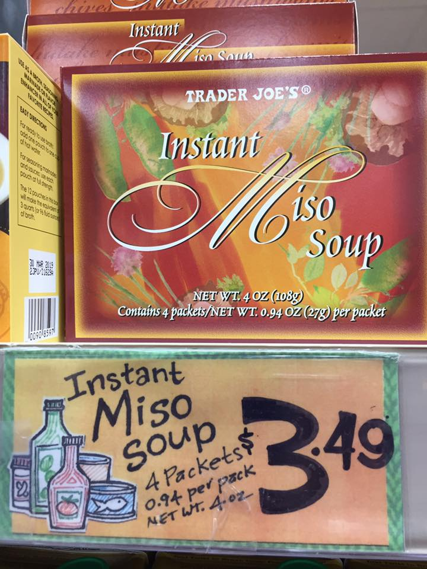

Creativejuicesconsulting.com © 2017

